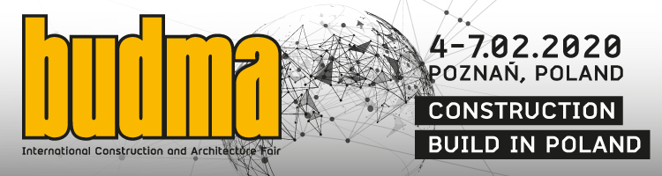

BUDMA 2020 - the most important contact point for the construction industry in the CEE
The past meeting of the construction industry, BUDMA Fair, was noted by the organizers as record-breaking. Indeed, a lot was happening in Poznań - nearly 1,000 exhibitors, about 50,000 trade fair visitors who unanimously confirmed that the huge business potential and development opportunities were visible in every exhibition pavilion. It was impossible not to notice the large turnout of guests from abroad, as conversations in foreign languages ​​resounded at most stands, and therefore one can be tempted to say that many of these contacts resulted in new, fruitful contracts.
The next fair, which will take place at the beginning of February 2020 (February 4-7) promises to be equally impressive. The organizers emphasize that they already have more registered companies compared to the same period last year. The Hosted Buyers Programme (buyers from the most important distribution networks from countries with high import potential for construction products) is very popular. We already know that in Poznań we will meet buyers from such countries as: Ukraine, Belarus, Russia, Tunisia, Lithuania, Greece, Georgia, Czech Republic, Slovakia, the Balkan countries, as well as from the most important Polish export markets: Germany, France, Scandinavia, Italy or also Spain.
In less than five months Poznań will again become the most important contact point for the construction industry. It is here that the major manufacturers and distributors of building materials will talk with traders, architects, professionals and investors about their experiences, ideas, market premieres and nonelties. 4 days in Poznań is also a series of extremely interesting events, both substantive and interactive. Among them, special attention should be paid to the Build 4 Future Economic Forum of Construction, the next installment of Monteriada (correct techniques of joinery assembly presentation), the Forum of Design and Architecture, as well as the championship of young roofers and parquet flooring.
Companies that would like to present their offer during the BUDMA fair should note the date October 1 - until this day the so-called the first application deadline, in which the most attractive price offer for participation in the fair applies.
The next BUDMA fair will be accompanied by the INTERMASZ construction machinery and equipment fair, the INFRATEC fair for technology and materials for infrastructure construction, and the fireplace industry fair KOMINKI.
BUDMA International Construction and Architecture Fair, 4-7 February 2020, Poznań.
www.budma.pl/en

